Characteristics and mechanisms of subjective rhythmization

Rasmus Bååth*
Lund University Cognitive Science, Sweden
*E-mail: rasmus.baath@lucs.lu.se

Subjective rhythmization is the perceptual illusion that the monotone sounds of metronome sequence have different intensity and that these differences follow a regular pattern. This pattern has a metrical structure and causes the impression that there are groups of sounds. Resonance theory, a dynamical systems theory of rhythm perception¹ has been used to explain why subjective rhythmization occurs. The present study aimed to replicate and extend the only two studies that have employed the original SR experimental paradigm^{2,3} and to test a number of predictions developed using the resonance theory explanation. Nine female and 21 male participants were asked to attend to isochronous sequences of click sounds, presented at ISIs ranging from 150 ms to 2000 ms, and to report the ﬁrst grouping they experienced. In addition, a synchronization task was administered in which participants tapped along to metronome sequences of different tempi.
The results of the current study are in accordance with earlier studies on subjective rhythmization. The most common groupings participants reported were two and four, the groupings of common meters of western music, and group size and tempo interacted as participants tended to perceive smaller groupings at slower tempi and larger groupings at faster tempi. Figure A shows the relative frequency of the reported groupings as a function of the interstimuli interval (ISI) of the monotone metronome sequence. A number of predictions developed from resonance theory were also conﬁrmed by the experiment. The mean group period as function of ISI was found to be well described by a power function, as shown in Figure B. There was also a strong correlation between participant’s responses in the subjective rhythmzation task and timing performance in the synchronization task.

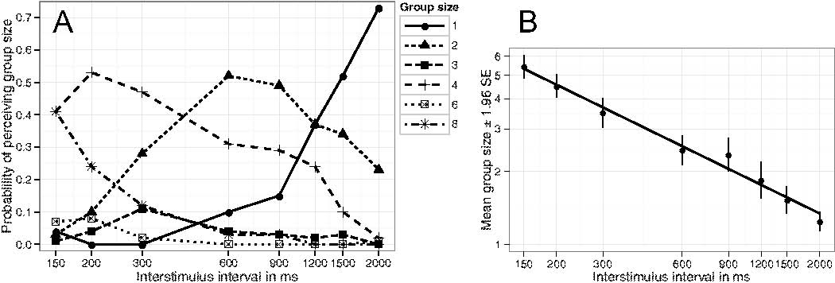

References
1 E. W. Large, M. R. Jones, Psychol. Rev. 106, 119–159 (1999).
2 T. Bolton, Am. J. Psychol. 6, 145–238 (1894).
3 P. Vos, Waarneming van metrische toonreeksen (Nijmegen: Stichting Studentenpers, 1973).

Sources for age-related changes in the timeline for segregating a speech target from a background masker

Boaz M. Ben-David *^{a,b,c}, Meital Avivi-Reich^{b}, and Bruce A. Schneider^{b}

ªInterdisciplinary Center (IDC) Herzliya, Israel
^{b}University of Toronto, Canada
^{c}Toronto Rehabilitation Institute, Canada
*E-mail: boaz.ben.david@idc.ac.il

Listening to your native language spoken in a quiet environment is virtually effortless. However, the addition of competing sounds increases listening difficulty. The listener must perceptually seg-regate the target speech from the competing sound sources (stream segregation¹). Our previous paper² showed that word recognition improved for young English-as-first-language participants (EFLs) as we increased the time-delay between masker onset and the target word onset. We ar-gued that the prior onset of the masker by a few hundred ms allows representation of the masker as a distinct auditory object. In turn, this facilitated the listener’s ability to perceive the target word as a second and distinct auditory object.

Notably, older EFLs were as good as younger EFLs when the masker was noise, but did not show any benefit of having a multi-talker babble masker precede the target word. We argued that both younger and older adults could rapidly build up the noise as an auditory object as the acous-tic properties of the speech token and the noise masker differed substantially from each other. However, the acoustic and phonetic similarity between the babble and target word is likely to impede the formation of the babble as an auditory object. The poorer performance of older adults with a babble masker could be thus attributed to age-related auditory declines. An alternative hypothesis is that declines in older listener’s linguistic and semantic processing abilities made it more difficult to perceive the word as distinct from the babble.

Here we investigate these two hypotheses. We compared our previous results with the ability of younger English-as-a-second-language (ESL) speakers to benefit from a delay between masker and word onset. Noting that hearing acuity and acoustic processing is the same for younger adults regardless of language experience. If the difficulty experienced by older adults with a babble masker reflected age-related declines in auditory processing, we would expect both young ESL and EFL groups to benefit similarly from word-onset delays. If younger ESLs perform like older EFLs with a babble masker, this would support the alternative hypothesis: Relating poor performance to age-related declines in phonemic or semantic processes.

Results: ESL and EFL younger listeners were comparable in the speed for segregating speech from both noise and babble maskers. These groups only differ in the asymptote of the functions. The data indicate that the unique difficulty seniors experience with a babble masker stems from age-related auditory degradation and not from semantic = linguistic differences. Taken together, the two studies are consistent with a sensory degradation account for age-related declines in cog-nitive tasks³. Apparent declines in performance in speech tasks may arise because the sensory information delivered becomes degraded with aging.

References

- A. S. Bregman, Auditory Scene Analysis (Cambridge, Massachusetts: The MIT Press, 1990)
- B. M. Ben-David, V. Y. Y. Tse, B. A. Schneider, Hear. Res. 290, 55–63 (2012).
- B. M. Ben-David, B. A. Schneider, Aging Neurpsychol. C. 16, 505–534 (2009).

G.Th. Fechner: correcting historical misrepresentations

Ehtibar N. Dzhafarov*ª and Hans Colonius^{b}
- Purdue University, West Lafayette, USA
- Carl von Ossietzky University, Oldenburg, Germany
*E-mail: ehtibar@purdue.edu

Fechner has been criticized for faulty mathematical derivations. This is misunderstanding, even if largely due to Fechner's own expository shortcomings. Fechner derives his logarithmic law in two ways, neither of which uses the notion of JNDs or Weber's Law in its traditional understanding. Instead they make use of the following postulate, which we will call “W-principle”: Subjective dissimilarity between stimuli with physical magnitudes a and b (provided o ≤ a ≤ b, where o is absolute threshold) is determined by the ratio of these magnitudes, b/a. Fechner uses the term “Weber's Law” for both Weber's Law and the W-principle, creating thereby lasting confusion. Stated rigorously, the W-principle says that
D(a, b) = F (b/a) , | (1)
where F is some function, and the subjective dissimilarity D(a, b) has the properties of unidimensional distance: D(a, b) = 0 if and only if a = b; otherwise it is positive and D(a, c) = D (a, b) + D(b, c) . This additivity property is central for Fechner's theory, as he repeatedly states when discussing the notion of measurement.
Equation 1 implies
F (c/b) + F (b/a) = F (c/a) . | (2)
By trivially transforming this equation into the Cauchy functional equation on positive reals, its only regular (in particular, nonnegative) solution is D(a, b) = K log ^{b}_{a} , where K is a positive constant. Except for some unexplicated assumptions, this is Fechner's derivation presented in Ch. 17 of his Elements ¹. This very “modern-looking” derivation was overlooked by all Fechner's critics.
Ch. 16 of Elements contains another derivation, this one well-known but still misunderstood. It reduces Eq. 1 to a differential equation. Assuming that F (x) is differentiable at x = 1,
$\text{D}\left(\text{a,}\text{a+da}\right)\text{= }\text{d}\text{D}\left(\text{o,a}\right)\text{= K }\frac{\text{da}}{\text{a}}$ | (3)

where K = F′ (1). This is Fechner's Fundamentalformel, whose solution is the logarithmic function. The derivation is sound, the much-derided “expedient principle” mentioned by Fechner being merely his inept way of pointing at a trivially true property of differentiation.
If, in addition to the W-principle, Weber's Law happens to hold too, together they imply the “Fechner's postulate” D(a, a′) = const, where a′ is the stimulus just-noticeably greater than a. Fechner correctly tells us that if this constant is sufficiently small, then D(a, b) is approximately proportional to the number of just-noticeable differences that fit between a and b.²

References and notes

- G. Th. Fechner, Elemente der Psychophysik. (Breitkopf & H¨artel, Leipzig, 1860)
- For a detailed analysis of Fechner's theory and its relation to Fechner's threshold measurements, see: E. N. Dzhafarov, H. Colonius, Am. J. Psychol. 124, 127–140 (2011).

